TEAM #10549 Page 1 of 25

Team Control Number
10549
Problem Chosen
A
2020
HiMCM Summary Sheet
Summer jobs have become an increasingly popular topic among high school students these days. They provide invaluable enrichment opportunities to make money and gain experience and skills. However, due to the outbreak of coronavirus, it is more challenging for high school students to identify the most appropriate summer jobs for them. To help high school students find the best summer job options effectively and efficiently, it is important to examine the variables associated with summer jobs.

We first identify related variables and collect data useful to our model. We consider 22 different summer jobs and consider variables including income, company size, risks, comfort, and skills to be gained. These are often the strongest motivators for high school students seeking summer job opportunities, so incorporating them is essential.

For the overall model, we adopt an Analytic Hierarchy Process to evaluate the weights or relative importance of each variable for each individual. The process is based on the user's subjective evaluation of their personal preferences. In order to address this subjectivity, we also introduce the Entropy Method to analyze the summer job options. Combining the weights we calculate from both models, we then obtain the overall weighting used for each individual. These weights are then applied on the summer job options we have. However, considering students usually want to have an array of open options to choose from, we utilize K-Means clustering rather than simply returning the one single “best” job. Then, the best cluster of job options is output to our user.
In regards to the fictional characters, we develop 10 different characters that we believe are highly representative of the US high school student population. Application of our
developed model onto these fictional characters indicates that our model is fairly effective in identifying the most appropriate summer jobs for students.

For the optimized model, we recognize that high school students are very likely to input inconsistent matrices, which will result in ineffective evaluation of the model. If this occurs, it would be tedious to force students to re enter their information until the result becomes consistent. Consequently, we optimize our model by adjusting the values stored in the original matrix that is unsatisfactory. Then, a more consistent comparison matrix that still demonstrates overall relations among the variables can be used for our model. While our model is in no way perfect, we believe it is a comprehensive system that takes sufficient variables into account. Furthermore, we have combined the AHP model, Entropy system, and our optimized model to develop an overall fairly realistic, effective, and objective mathematical model.

Keywords: Summer jobs; Analytic Hierarchy Process method; Entropy Weight method; K-means Clustering; Optimized model

GET A JOB!
NOVEMBER 17, 2020



HOW TO FIND THE
BEST SUMMER JOB?
Have you ever felt frustrated from finding the best summer job for you? Well, you are not alone. Now due to the COVID-19 outbreak, it becomes even more difficult for high school students to find suitable summer jobs.
Thankfully, you don't have to stress about that now! Our research constructs a straightforward model for high school students to
use. Our model allows you to simply enter your personal information and goals for the job, and it will quickly return the best summer job options for you! Our model incorporates jobs' income, comfort, skill level, company size, and risks, as well as your personal situations and preferences, to make the best summer job recommendation. Furthermore, our app will offer you an opportunity to view other students' comments on the summer jobs, allowing you to further decide on which job would be the best for you personally.

What are you waiting for? Come and find yourself a job today!

SUMMER JOBS RECOMMENDER

BEAUTIFUL LAYOUT, STRAIGHTFORWARD MECHANISM, AND
EFFECTIVE RECOMMENDATIONS

According to our research, teen summer job has declined in the US. This model will provide personalized job recommendations for high schoolers.
TEAM #10549 Page 3 of 25

TABLE OF CONTENTS
1 ​Introduction 4
1​.1 ​Background 4 1​.2 ​Problem Restatement 4
2 ​Assumptions and Variables 4 2​.1 ​Assumptions and Justifications 5 2​.2 ​Variable Chart 5
3​ ​Models Overview 5 3​.1 ​Analytic Hierarchy Process 6 3​.2 ​Entropy Method 6 3​.1 ​Optimized Model 6
4​ ​The Basic Model for Considered Variables 7 4​.1 ​Deterministic Variables 7 4​.2 ​Probabilistic Variables 7 4​.3 ​AHP Model 8 4​.4​ Objective Weighting System using Entropy Weight Method 12 4​.5​ Combining AHP and Entropy 13 4​.6 ​Results and Analysis 14 4​.7 ​K-Means clustering 14
5​ ​Testing the Models 15 5​.1 ​Fictional Characters’ Development 16 5​.2 ​Results and Analysis 17
6​ ​The Optimized Model 18 6​.1 ​Model Construction 18 6​.2 ​Application of Optimized Model 19
7​ ​Evaluation of Model 20 7​.1 ​Strengths 20 7​.2 ​Weaknesses 20
8​ ​References 20
9 Appendix 21 9​.1 ​Appendix A 21 9​.2 ​Appendix B 24 9.3 Appendix C 25
TEAM #10549 Page 4 of 25

1. Introduction
1.1 Background
In recent years, summer jobs have become a hot topic among high school students. From restaurant waiter and babysitter to data analyst and research assistant, summer job opportunities encompass a very wide spectrum. Furthermore, not only do they serve as sources of income for high school students, but they also enrich students with invaluable skills and experiences that will be vital to their future major and career. However, as global pandemic COVID-19 continues to roar throughout the world, it becomes progressively more challenging for high schoolers to efficiently and accurately identify the best summer jobs for them in the year to come. Pew Research Center suggests that teen summer jobs become less common in the US [5]. Due to the pandemic, it is also more difficult for students to seek out professional support about finding the most suitable job for them. As such, helping high school students look for the best job for them becomes our problem to solve. Therefore, this paper analyzes the relevant models such as AHP and optimizes them in order to develop a summer job evaluation system that recommends the most suitable jobs to the user.
As high school students often lack a comprehensive and objective understanding of their own needs, we also adopt an optimized model that will address the potential inconsistency in students’ input comparison matrix. Considering the subjectivity problem, we will also apply more objective methods like Entropy Method by taking the entropy of information into account.

1.2 Problem Restatement
The essential question is to develop a model to suggest optimal summer job options to
high school students. The question can be broken down into the following subquestions: Question 1: ​We need to identify all the variables that high school students today
would consider when looking for a summer job. We also need to collect data on common summer jobs about the variables that high school students will likely consider.
Question 2: ​Using the variables identified in question 1, we need to develop a recommendation system that assigns different weights to different variables based on individual abilities, preferences, and situations. This model should be applicable to any high school student and can return the most appropriate job option.
Question 3: ​Use Entropy Method to offset the subjectivity problem that arises from question 2. Make objective ranking of the jobs and then combine the two results to form a better, more objective model.
Question 4: ​We need to develop ten fictional characters that are representative of the entire high school student population. Discuss the effectiveness of our model when it is applied on each fictional person.

2. Assumptions and Variables
2.1 Assumptions and Justifications
Assumption 1: The United States is our primary region of concern. ​Since high school summer jobs are relatively very common in the United States, there is a vast source of
data for us to utilize. This makes it easier to test our proposed model.
TEAM #10549 Page 5 of 25

Assumption 2: All jobs of the same kind have the same salary, work time, and company size. ​While it is true that there are variations in salary, work time, and company size even for the same type of job, it is safe to neglect that variation for the purpose of
modeling.
Assumption 3: High school students have perfect knowledge about their summer
plan. ​We assume high school students have perfect knowledge about their plan in summer. This means that they are well aware of the recreation activities and social events they will have in summer. This allows them to better plan their summer job.
Assumption 4: High school students get paid equally and fairly in summer jobs. Because there is limited data on salaries paid specifically for high school students, we must assume high school students receive the same payment as the amount we found online. It is reasonable to make this assumption, since salaries received from summer jobs generally do not deviate significantly from the average salary we identify.

2.2 Variables Chart
The table below defines all the variables we will use throughout this paper:

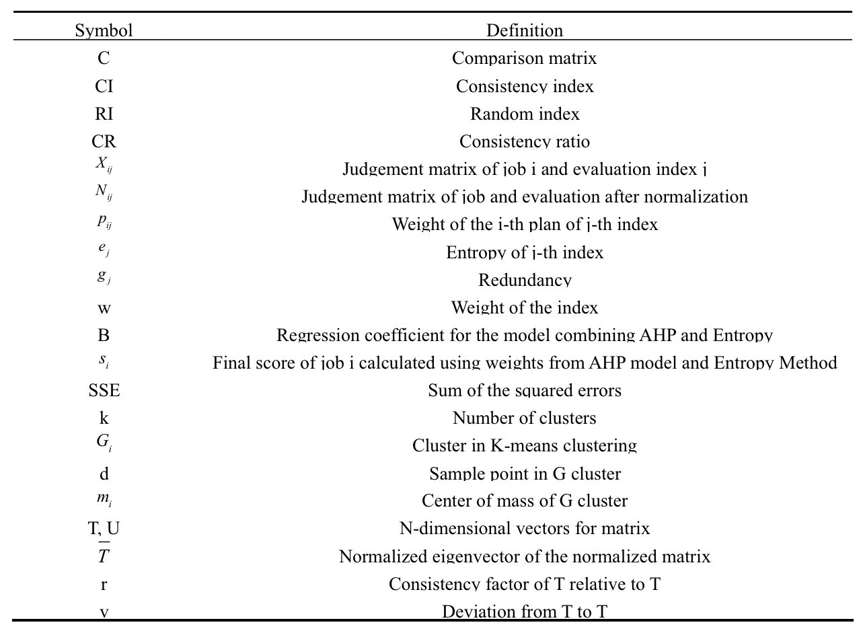

3. Models Overview
3.1 Analytic Hierarchy Process
As mentioned earlier, identifying variables that high schoolers consider is the first
step. To make the model effective, these variables will be arranged in a hierarchical structure.
We employ the Analytic Hierarchy Process (AHP) to evaluate the importance of each
variable to the user. The advantage of AHP is that it can display complicated selection factors
TEAM #10549 Page 6 of 25

in simple concepts of hierarchy, which can be accepted easily by a decision-maker [6]. We have considered a wide range of variables, using subjective opinions. By using the AHP model, we are able to rank the weight of each variable for individual users in order to identify the best job for them. All job options will be tested against the basic model, and an index will be calculated for each job.

3.2 Entropy Method
However, the AHP model itself is susceptible to subjectivity. In conjunction with
AHP, therefore, we also apply the Entropy Method to address the subjective aspect of our model. Using the quantitative variables we have collected about summer job options, including hourly rate, work time, and company size, we calculate a weight for each subset by deriving their entropy. We can then combine the summer job lists results from both AHP and Entropy Method to obtain a better subset of suitable jobs for the user.
The flow chart below shows a clearer logic:

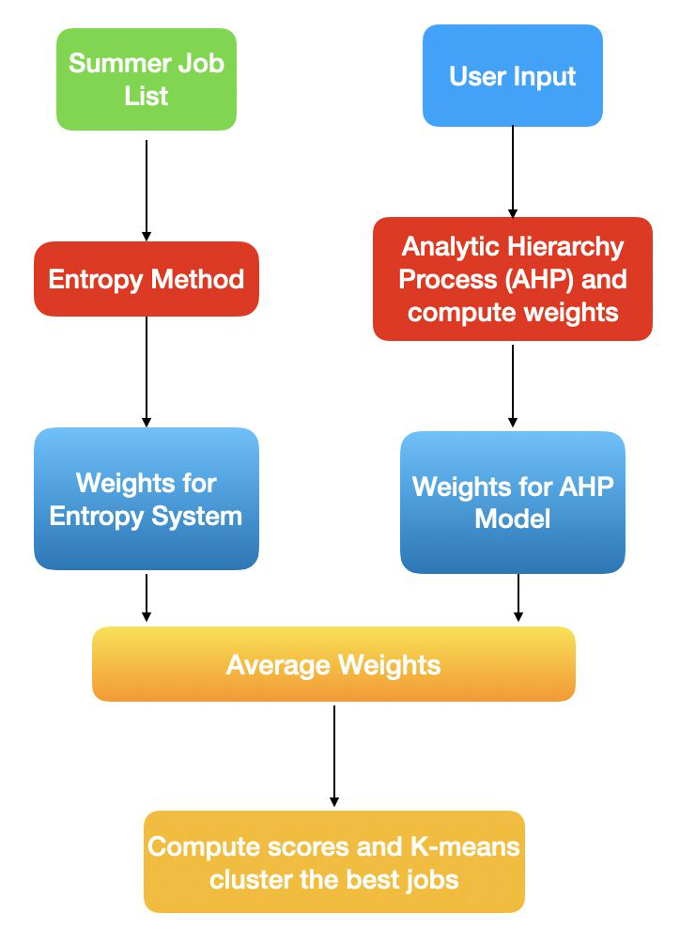

Figure 1​: Logic flow for our basic model

3.3 Optimized Model
Considering that high school students usually lack a comprehensive and objective
understanding of their true needs and situations, we must assume that the comparison matrix directly given by them would be very likely inconsistent. We thus develop an optimized model for modifying the given inconsistent matrix to be consistent (while maintaining the original information). This section will be discussed toward the end as part of optimization of our model.
TEAM #10549 Page 7 of 25

4. The Basic Model for Considered Variables (Questions 1 and 2)
The most basic model for evaluating the best summer job is a function between a
summer job’s utility and other independent variables, including the job’s income, comfort, type of job, company environment, relevance to intended major/career, age and ability requirements, and risks. In order to evaluate the significance of each, we adopt the Analytic Hierarchy Process (AHP) to derive the weight for them. In order to analyze our model, we first outline and explain the variables we use for the study, then we explain the AHP model, and finally apply it on fictional characters for testing.

4.1 Deterministic Variables
Certain variables in jobs predetermine whether high school students may participate
in the job. These are the basic requirements for the job, and they must be met as prerequisites. Because we are primarily concerned with high school students, one important consideration
is the age requirement for the job. If a student is too young to undertake some cumbersome physical activities, they cannot choose the job. Another possible deterministic variable is ability prerequisite. However, our team decides to put that as a probabilistic variable, since in our opinion, in the age of high school, students should do something that can challenge themselves, which a skill-required job is more valuable than jobs with no ability requirement.

4.2 Probabilistic Variables
In this section, we consider variables that do not predetermine the types of jobs that
students can choose. They are among the most important variables for high school students based on secondary sources [7] and in our perspective as high school students.
● Income
For many high school students, the income of a job is a crucial factor. Students who
confront financial difficulties at home especially need jobs that offer higher salaries. The total income earned through working at a job, M, can be defined as
M = R × T
where R is the hourly rate (in dollars per hour) and T is the total work time (in hours). We
collect data on our summer job options’ income using a variety of sources online, including Investopedia, Indeed, and Zipecruiter. Note that work time could also be a deterministic variable, as there is an upper limit for the amount of time available for students.
● Comfort and Type of Job
Especially during COVID-19, the nature of the job (i.e. virtual or in-person) could be
a critical factor for selecting a summer job. We consider three independent probabilistic variables under this category, including virtual or not, sedentary or not, and the location of
the job. The first variable depends on the local pandemic situation as well as individual preference for safety. The other two variables may depend on the student's personality and economic needs.
● Company characteristics
Company’s features are factors usually considered by high school students as well.
One consideration is the size of the company, which heavily influences student’s decisions,
TEAM #10549 Page 8 of 25

as some students may prefer individual work over teamwork. We vaguely define the size of the company, N, as the number of faculty employed.
● Risks
High school students likely want to minimize the danger associated with any summer
job. One consideration may be the prevalence of COVID-19 in the region. According to Yonatan Grad, an epidemiologist at Harvard T.H. Chan School of Public Health,“The total incidence of [coronavirus infection] through 2025 will depend crucially on this duration of immunity"[8] Since this novel disease is unpredictable, we must take this into account as we are aiming at identifying the best summer job for students in 2021. As risks are often poorly defined, we adopt a Risk Score, RS, on a scale of 1-5 to assess the possibility for employees to encounter danger. One on the scale represents the lowest level of risks, which corresponds to jobs that are sedentary, indoor, or virtual. By contrast, works that require outdoor experience and first-aid experience are more likely to attain scale three. For all jobs, we would like to minimize RS. Risks of COVID-19 are also considered.
● Skills
High school students also intend to gain skills and experiences through summer jobs.
Consequently, they want summer jobs that are relevant to their intended major or career. We define a skill index on a scale of 1-5 to determine how challenging the job is in terms of its ability requirement. For students looking for more advanced experience, jobs with higher ability index will fit them.
More compactly, the following is a schematic of the variables this study considers.

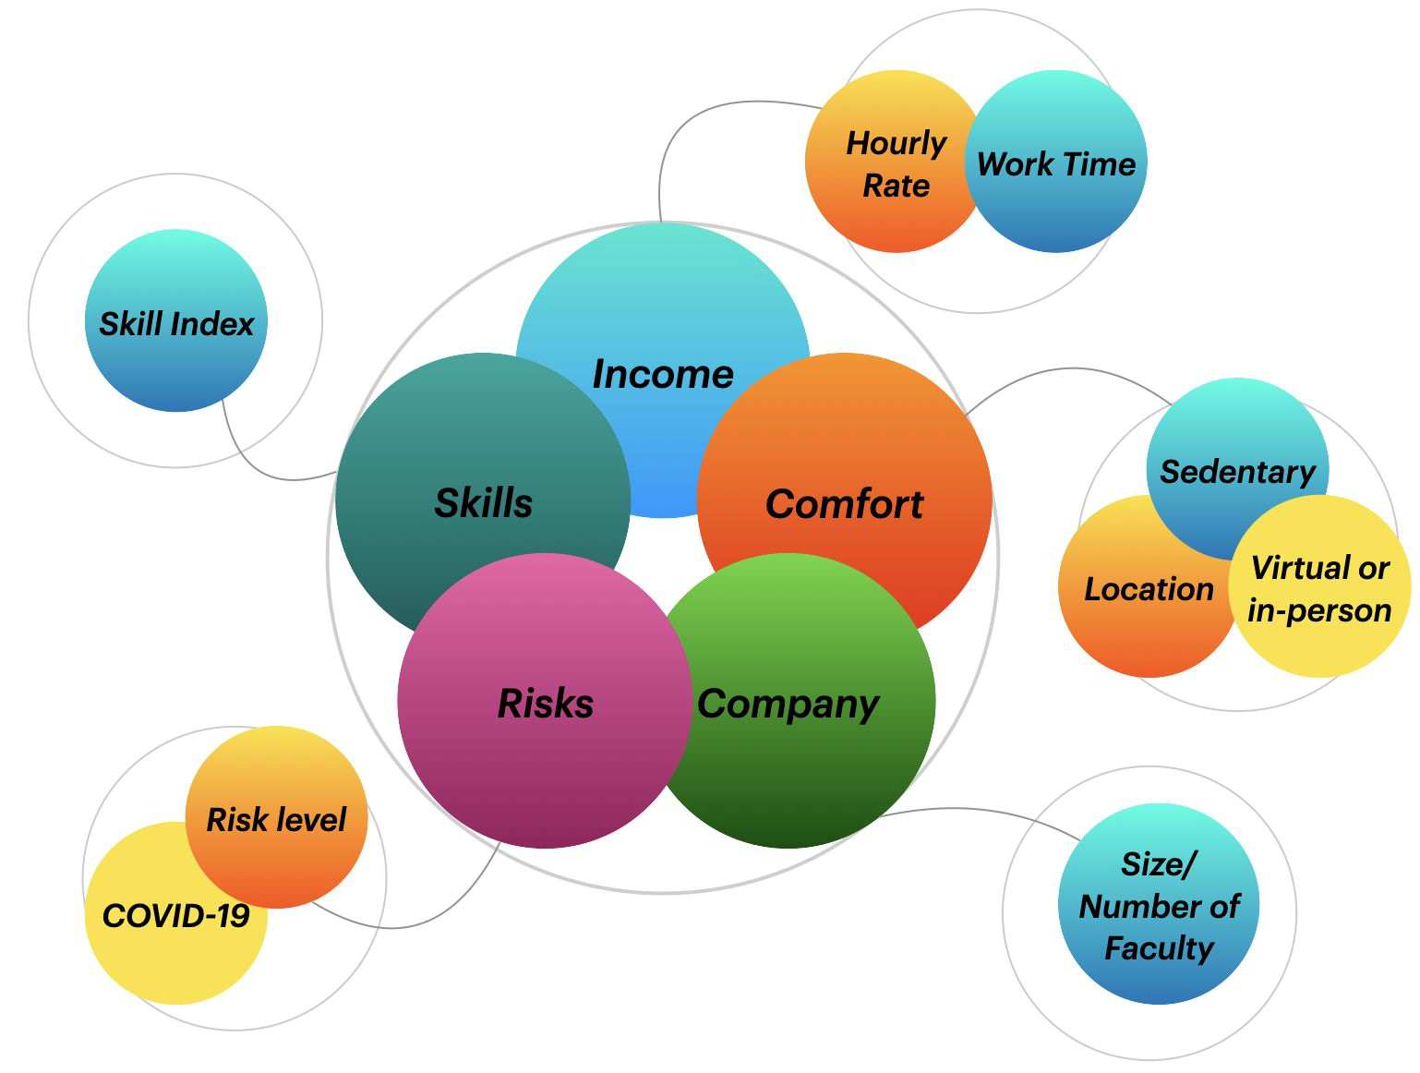

Figure 2​: An overview of the variables this study considers

4.3 AHP Model
Having established the variables we need to consider, the following subsection will
attempt to solve for the weights of each variable. This allows us to assess the relative importance of each variable, thereby letting us recommend the best summer job for each
TEAM #10549 Page 9 of 25

student user. In order to achieve this, the AHP model is an appropriate method. First developed by Thomas Saaty in the 1970s, the AHP model deals with a hierarchy of variables and can calculate the weights of each variable. A hierarchy structure of our variables is summarized below.
Figure 3​: Hierarchy structure of variables

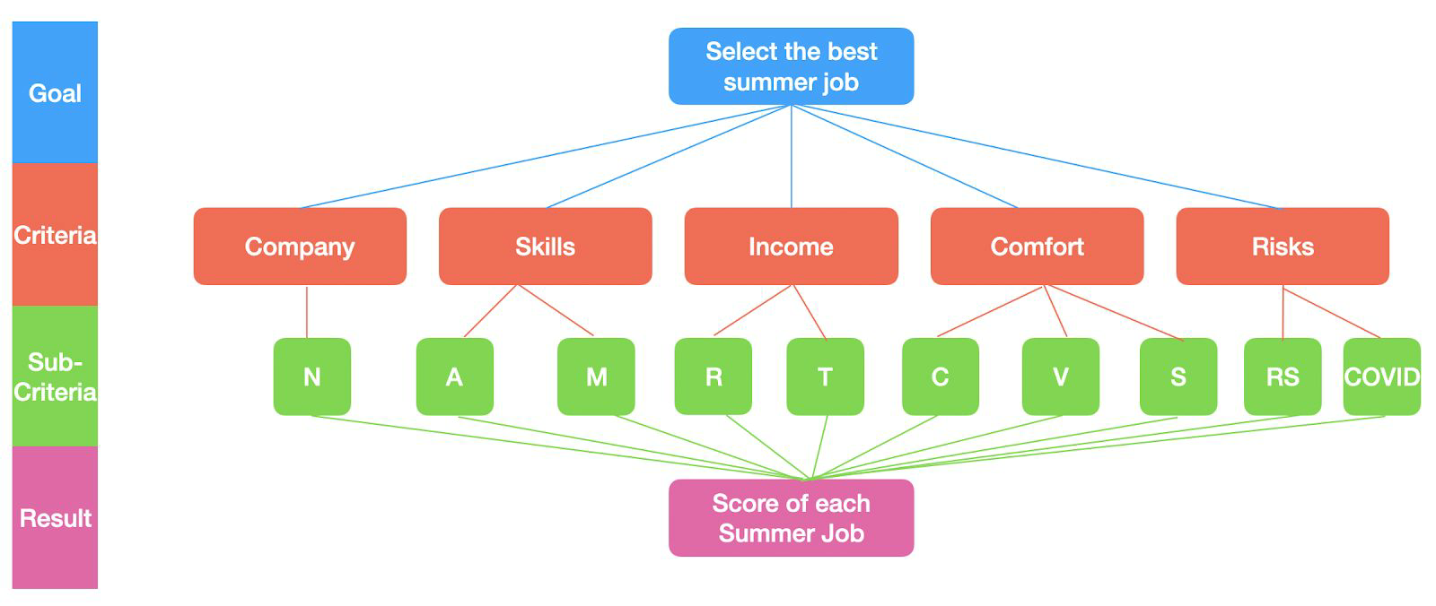

Variables Definition

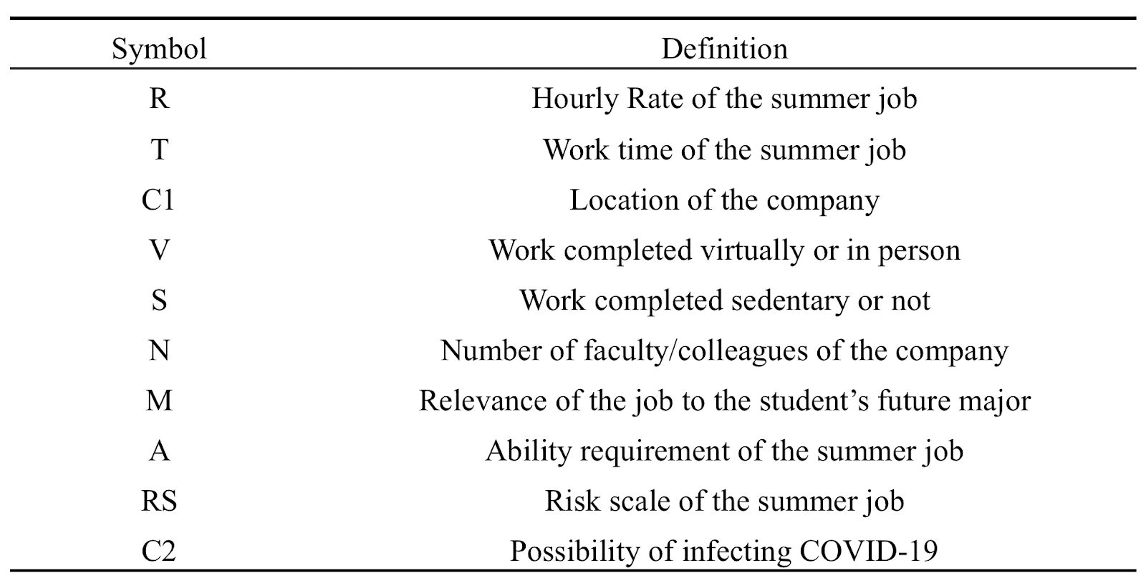

AHP model effectively structures variables into a hierarchy. It is a way of assigning variables different weights based on the accompanied 1-9 scale table, which compares the importance of different factors. It determines the relative significance of each variable.
TEAM #10549 Page 10 of 25

1-9 Scale Table
Scale Definition


1 factor is equally important as factor




3 factor is slightly more important than factor 5 factor is apparently more important than factor


7 factor is strongly more important than factor


9 factor is extremely more important than factor
2, 4, 6, 8 the intermediate values


Reciprocal importance scale between factor and factor




Based on the 1-9 scale table, it is possible to establish a comparison matrix for the variables. A comparison matrix is a square matrix of the following form. For each entry, represents the importance of relative to , as measured by the above scale table.

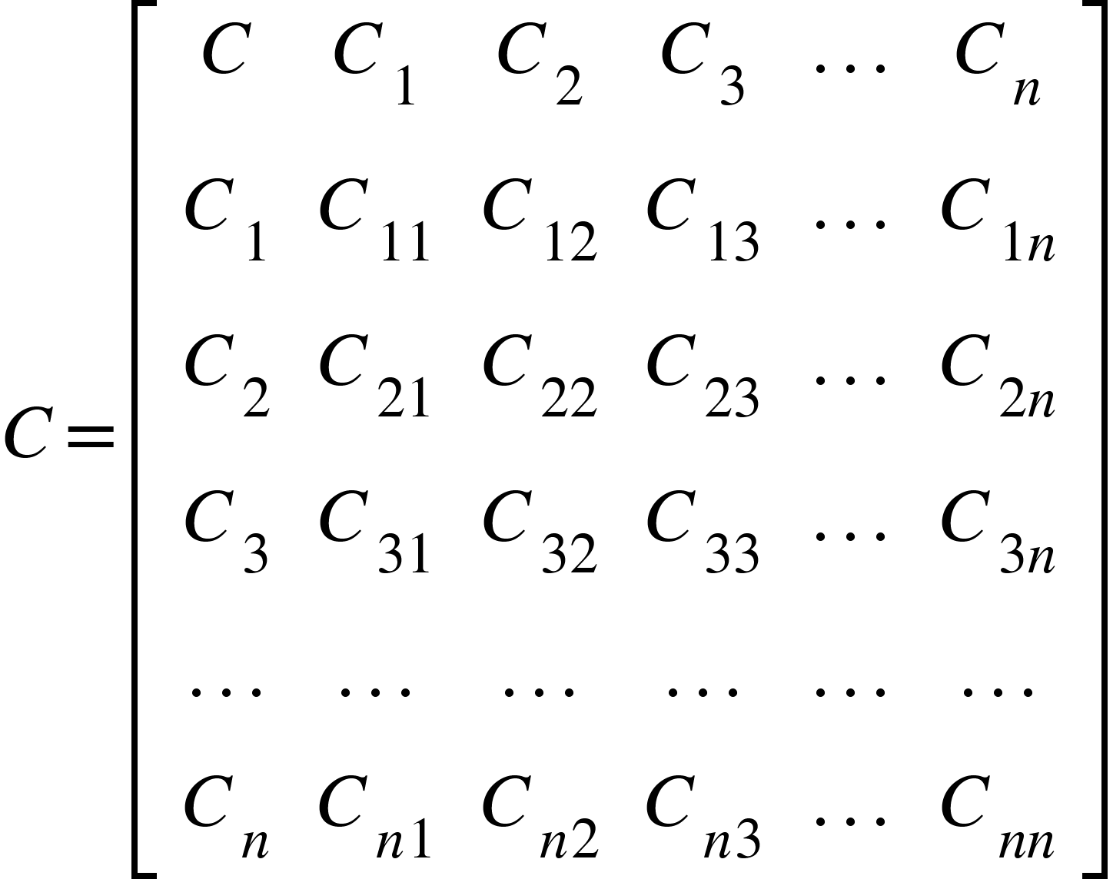

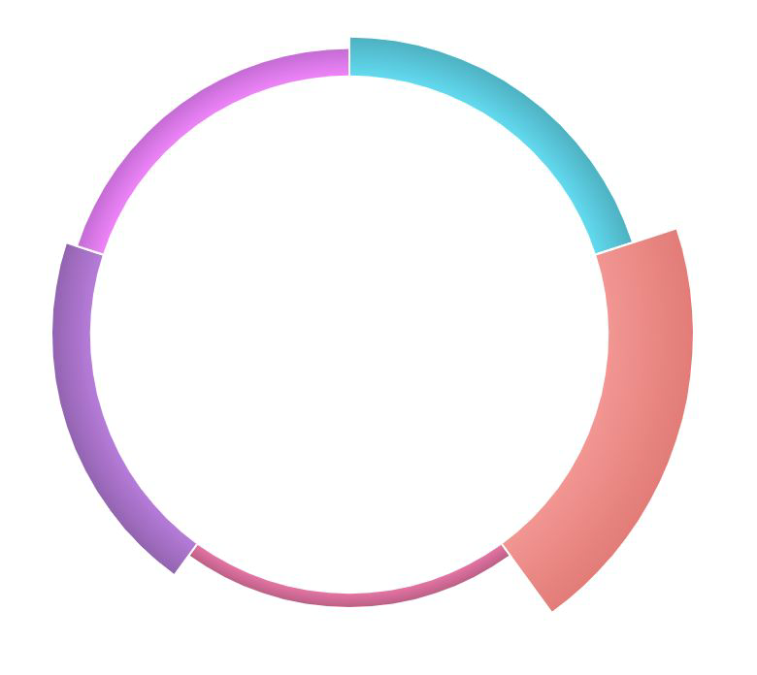
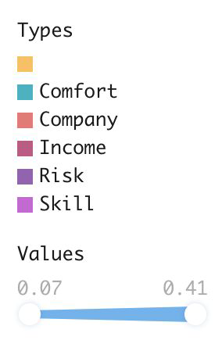
(3.1)
To evaluate the efficiency of the model, we construct a comparison matrix for a user
whose primary concerns are comfort and skills gained rather than money. For this hypothetical example, we consider a high school student, Christopher, who values company and more than the income. The student’s primary goal for the job is to expand his experience working in a large company. We accordingly compute her weights for the main criteria, as shown below:
Figure 4​: Rose diagram of weights for criteria
TEAM #10549 Page 11 of 25

We also compute weights for sub-criteria. The results are summarized below using the preference of Christopher:

Table 1. ​Comparison matrix and weights

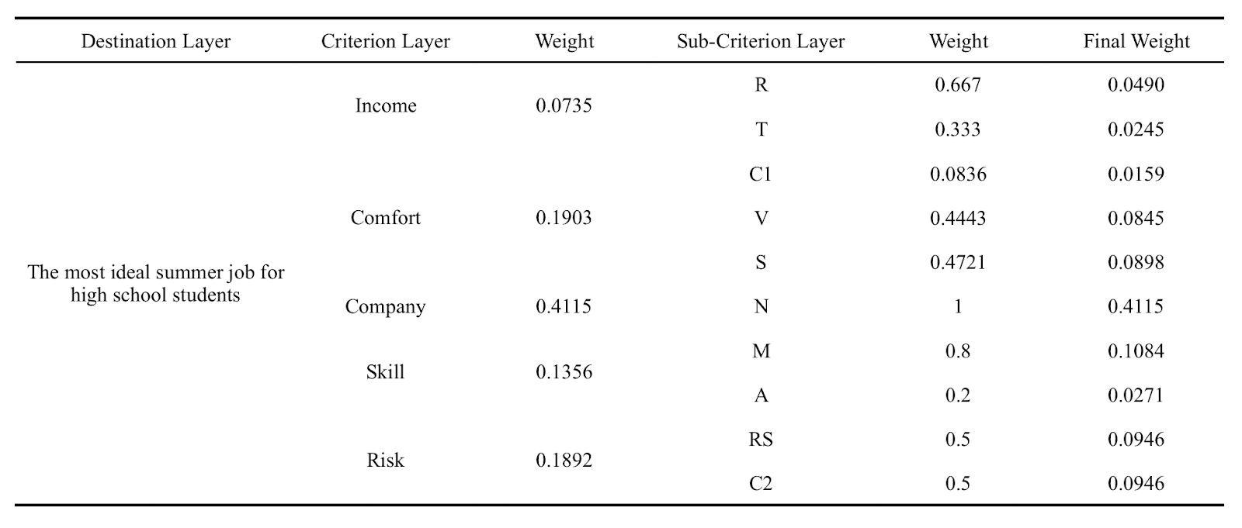

Furthermore, to confirm our assumption that the inputs are consistent and hence to verify that our fictional character is realistic, we consider the consistency of an n*n matrix with the greatest eigenvalue ​λ m​ax​, which can be expressed as the following:
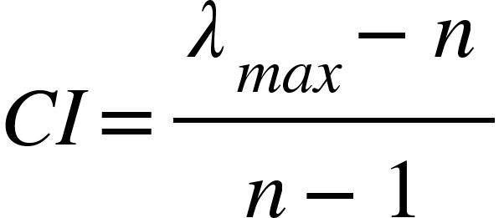
(3.2) After calculating CI, we further introduce RI and CR to determine if the level of
inconsistency stays within the tolerance range of 0.1.
Table 2​. Random consistency index

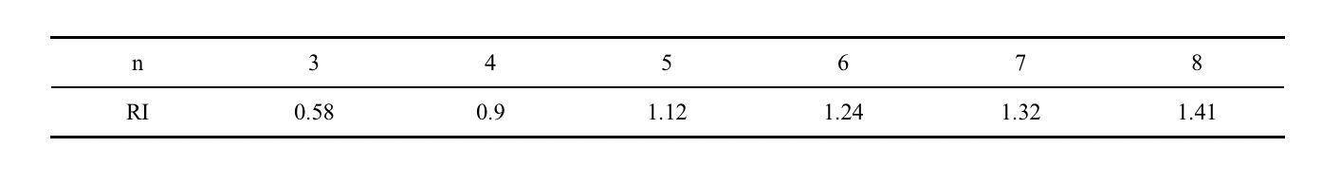

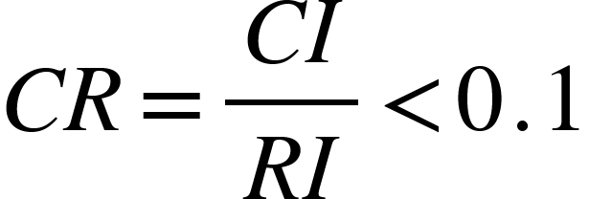
(3.3) Applying these formulas on our fictional matrix using Matlab, we confirm that CR is
always much lower than 0.1, meaning that our comparison matrix indeed is realistic and consistent.

4.4 Objective Weight System using Entropy Weight Method (Question 3)
Instead of solely depending upon the AHP method that gives us weight based on the
inclination of each high schooler, we also need to consider the degree of dispersion of the evaluation index that will in turn give us a more objective decision upon the optimal jobs for the high school students. Therefore, we adapted another evaluation method called Entropy Weight Method (EWM) that will calculate the information entropy of each index and derive the weight.
TEAM #10549 Page 12 of 25

Based on the summer jobs i, and the evaluation index j, we can build a judgement matrix: (n is the total number of jobs, and m is the number of index)
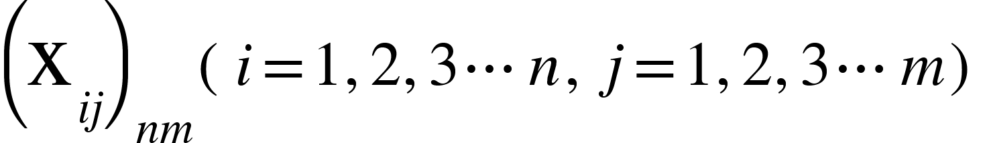
(4.1)
In our model, we classify the indexes into two categories:
1) Increasing (As it increases, the job is better: eg. salary)
2) Decreasing(As it decreases, the job is better: eg. work time)
Each index will have a different unit of measure. Thus, it is necessary to first have a normalization of the jobs, and get a matrix that will calculate the entropy. The calculations of
increasing and decreasing indexes are given in the equation below:

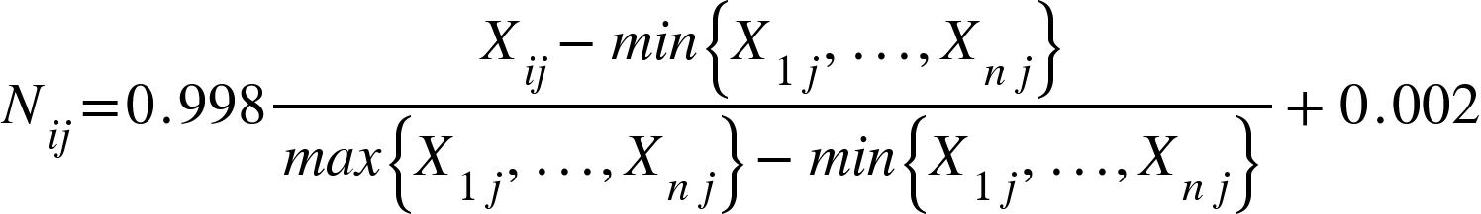
for increasing index (4.2)

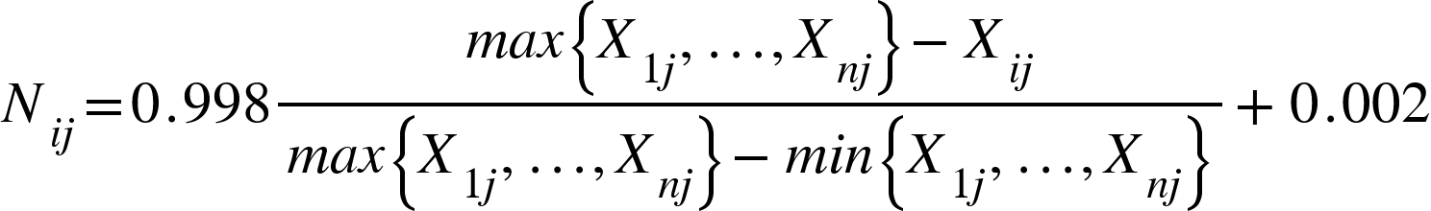


for decreasing index (4.3) After the normalization, we can calculate the weight of the i-th plan under the j-th
index through following formula:

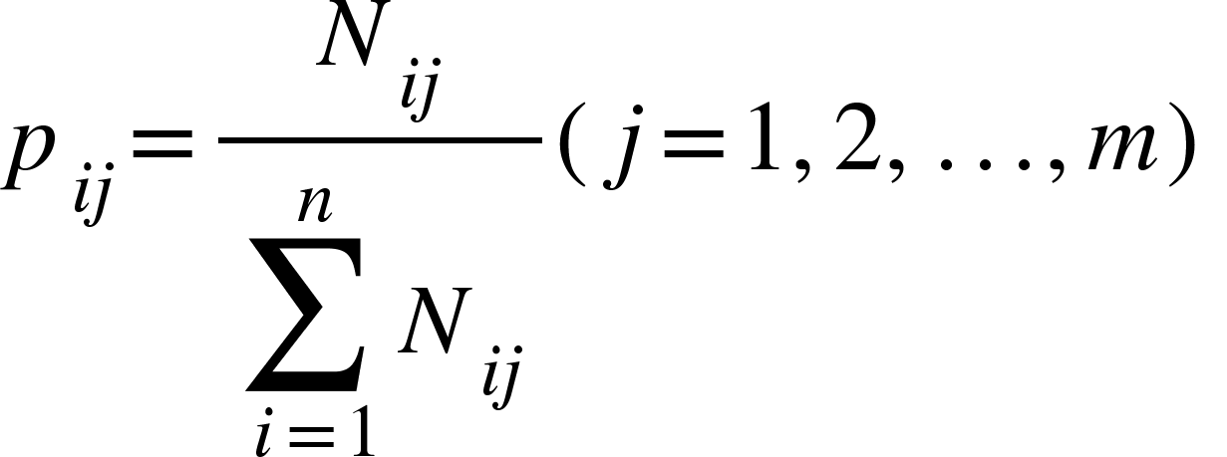

(4.4) Then the following can be used to derive the entropy of index j:
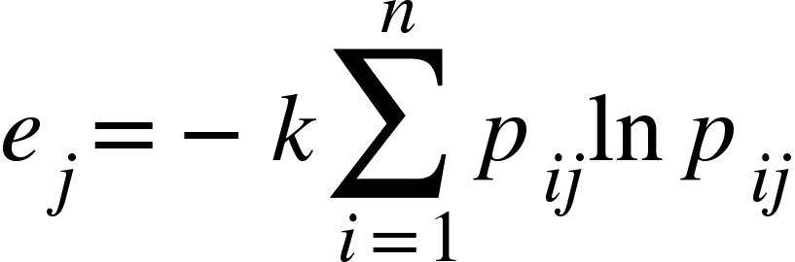
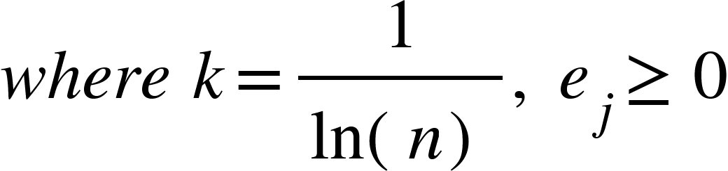
(4.5)

Based on the entropy, we can get the weight for each index

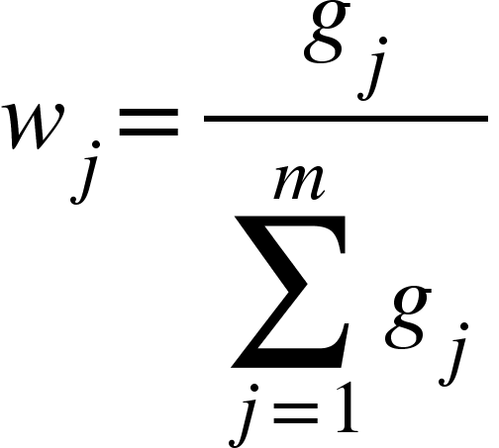

(4.6)

where is the redundancy​:
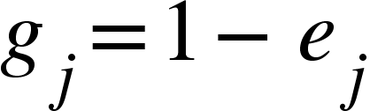
(4.7) Using the summer jobs list we define in the appendix, we can derive the weight of
each evaluation index as the following:
Table 3. ​Weights derived from EWM
R T C1 V S N M A RS C2 0.0386 0.0677 0.1179 0.0918 0.3159 0.0363 0.1651 0.0678 0.0650 0.0339
TEAM #10549 Page 13 of 25

4.5 Combining AHP and Entropy Method
As the AHP process and Entropy Method are both utilized, it is important to properly
combine the two models to effectively reduce the subjectivity of the AHP model. In order to bolster the accuracy and reliability of our overall model, therefore, we use the below formula to minimize the deviation between the AHP model and the entropy system:

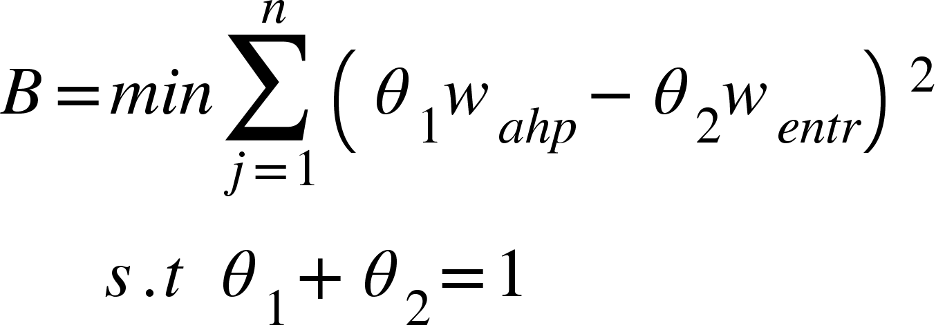



(5.1) where denotes the weight for the AHP model and denotes weight for the EWM. ​θ​1 and ​θ ​2 ​are constants for taking deviation into account. Together using ordinary least squares,




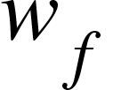
we could get the regression coefficient B that showed the ratio of j ​​to . Therefore,
it is easy to show that by adding and based on their proportion (u1&u2), we can
get the final optimized weight .

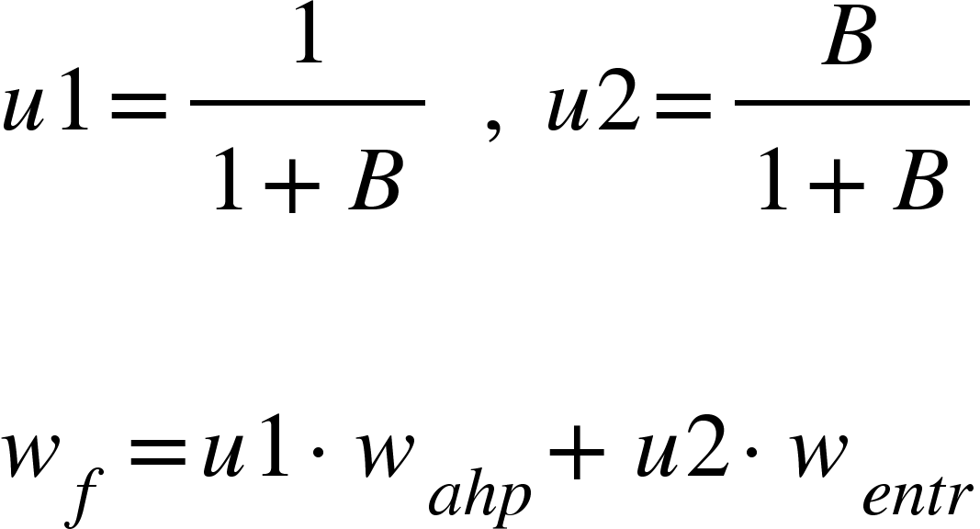

​ (5.2) As a result, we can get the final weight of each index based on both Christopher’s
personal preference and the objective evaluation of the index.

Table 4. ​Weights derived from EWM
R T C1 V S N M A RS C2 0.0455 0.0391 0.0505 0.0870 0.1665 0.2842 0.1276 0.0409 0.0845 0.0740

4.6 Results and Analysis
Based on Table 1, we derive the weights corresponding to the illustrative example.
We now define the index score for each summer job according to the following formula:
or in a more condense way:
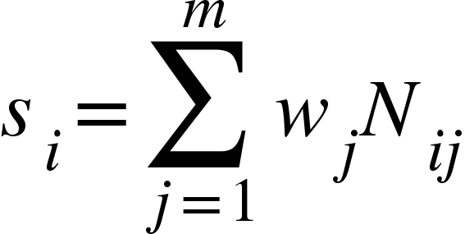


​(6.1) where is the final weight for indexes j, and is the normalized value of indexes j
for job i.
Accordingly, the higher the final score is, the better the summer job is for the individual. For our summer job list (see Appendix B), we compute that the job with the
highest index score is an online translator, which has an index score of 0.784. The values of all summer jobs calculated from our model for Christopher can be seen in the graph below:
TEAM #10549 Page 14 of 25

Figure 5. ​Job​ ​Scores for Christopher

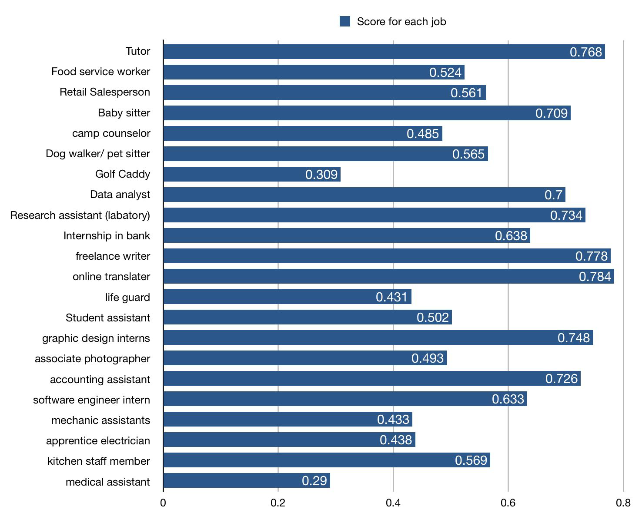

4.7 K-Means Clustering
Oftentimes, we want more than the one single best job. Rather, we want a cluster of
possible options. After using the AHP model and Entropy Weight method to assess the ideal summer job for a student, we use K-means clustering to further determine the exact classification of the student’s ideal summer job. The advantages of K-means are its simplicity of implementation, scalability, speed of convergence and adaptability to sparse data [9].
Using the Euclidean Distance formula as the criteria for comparing similarity and distance between value K and each point, we apply SSE (sum of squared errors) to determine the
exact value of K.
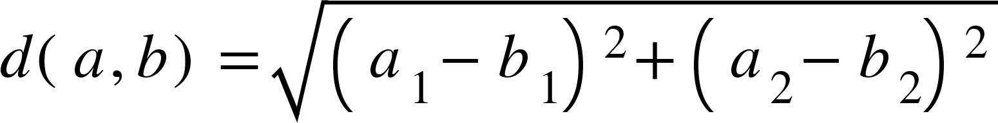

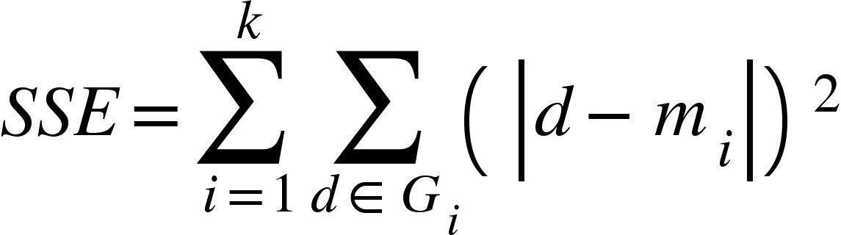

(7.1) When k, the number of clusters, increases, the clusters will be divided into more
precise groups that have higher clustering level. Thus SSE will gradually decrease. Furthermore, when k is less than the real optimal number of clusters, SSE decreases substantially since an increase in k will significantly increase the aggregation of the clusters. However, when k reaches the true cluster number, the return of the aggregation level of clusters will become rapidly smaller. Hence the decline of SSE is dramatically reduced,
TEAM #10549 Page 15 of 25

moving closer toward constant as higher k values. Below is the graph of SSE versus k using the final scores of summer jobs previously presented:

Figure 6. ​Relationship between SSE and K-values

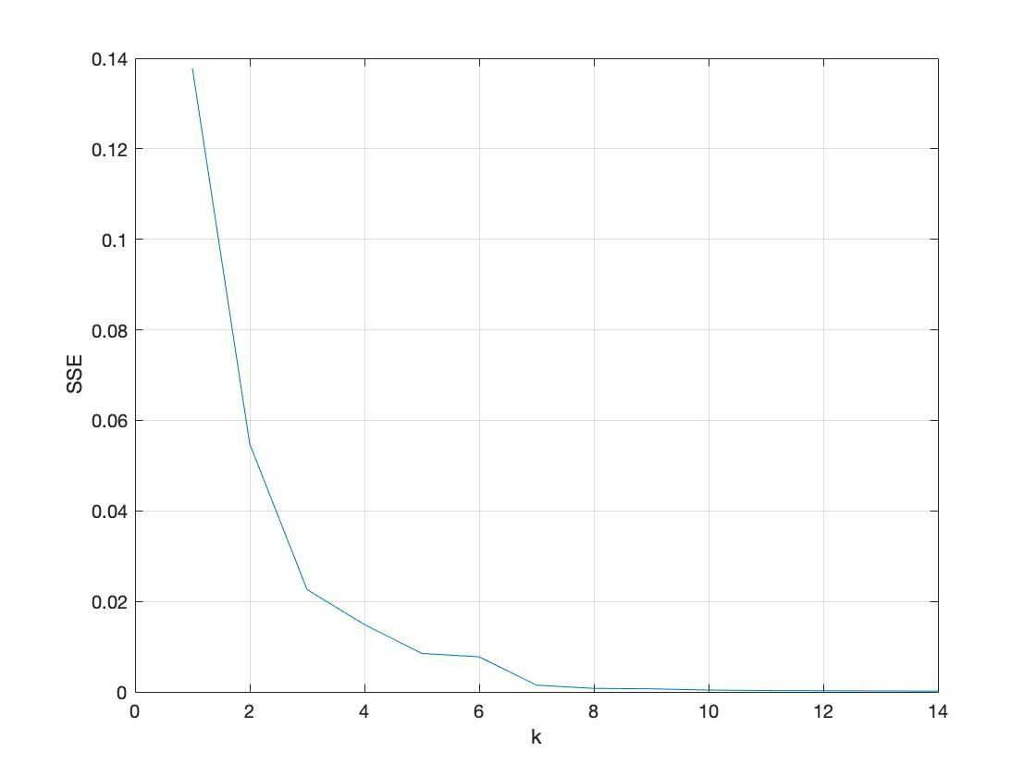

From the graph above, it is evident that SSE decreases with the increases in k value,
and the change of gradient is the greatest from k=2 to k=3, thus we choose k=3 as the final number of clusters. After applying the K-means clustering, we get the recommended list of Christopher’s summer list, which is the cluster that has the highest center. Finally, we use the deterministic variables mentioned earlier to eliminate undesirable jobs which in this case is the age requirement. Following is the final outcome of recommended jobs for Christopher:

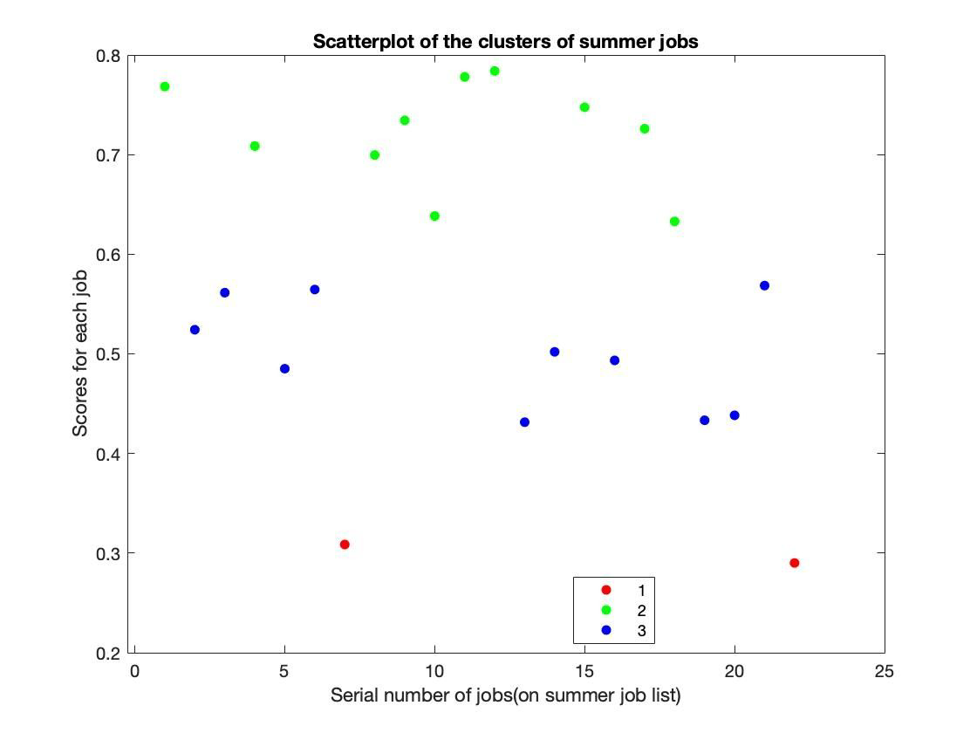
Figure 7.​ Scatter-plot for clusters of Christopher’s summer jobs
TEAM #10549 Page 16 of 25

Table 5. ​Best summer job cluster for Christopher

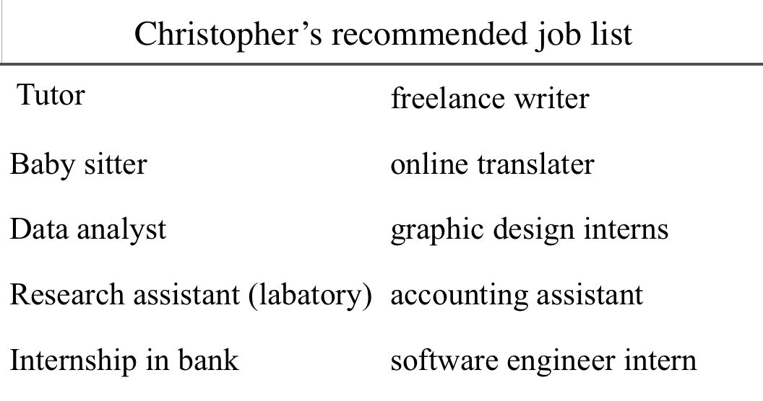

Indeed, this job list supports our initial hypothesis about Christopher, who values experience and company more than income. Jobs such as data analyst, research assistant, and
internship in a bank are the kinds of jobs that Christopher values, as they are often associated with larger companies and more advanced skills. This in turn validates our model.

5. Testing the Models (Question 3)
In the previous section, we explain our development of basic models and their quick
application on one fictional individual Christopher. In this section, nine other representative fictional characters are considered and tested against the previously developed mathematical models. While it is impossible to cover the entire high school student population
demographic and preference using only ten characters, we develop our subjects to be as consistent and diverse as possible, allowing us to better examine the usefulness of our model. We first provide our rationale and descriptions for the fictional characters and then explain
the model’s efficacy.

5.1 Fictional Characters Development
Our overarching rationale for the fictional characters is to make them as
representative as possible. High school students have different socioeconomic backgrounds, abilities, ages, and personal goals for doing summer jobs. In developing our fictional characters’ profiles, we consider how different students may place different relative importance on various variables. The comparison matrices and weightings for each variable for our fictional characters are summarized by Appendix A. Below we provide a basic profile for each fictional character (numbers in the parentheses indicate their age).
1. Anna (16) is a high school student interested in making more money. She doesn’t really care about the type of company she will be working for. She does pay attention
to her safety and comfort during the job, in addition to income.
2. Betty (17) is a high school junior whose primary concern is comfort. Her second
largest focus is income. Nevertheless, she doesn’t mind how skillful or large her job/company would be.
3. Christopher (Sample case described in the previous sections)(18) has a keen focus on company. He is not particularly interested in the income or skill that he will gain; it is the experience that appeals to him.
TEAM #10549 Page 17 of 25

4. David (15) pays a great deal to risks. Given the unprecedented circumstances of COVID-19, his top priorities are safety and comfort. He does not care about how
much he will earn or what company he works at -- safety comes first!
5. Erik (18) is an advanced high schooler interested in advancing his skills. At the same
time, he would also like to make more money for himself. As a hard-working student, his considerations for risks and comforts are minimal.
6. Fiona (17) also focuses on the company she would work at. But she also wants to earn
sufficient money for her summer fun time. Fiona isn’t really worried about the skills she may gain; her emphasis goes to company, income, and comfort.
7. Gary (16) is a high school student who focuses on the job’s risks and safety. His secondary consideration is the size of the firm. And frankly, he doesn’t care too much
about other things he will gain. He just wants a safe job for the summer.
8. Henry (18) prioritizes income and company. In fact, due to his poor socioeconomic
background, his emphasis on income is the highest among all our fictional characters. He is relatively unconcerned about the risks associated with the job, as long as he can earn money for his family.
9. Iris (15) is a high school student who focuses on skill and comfort of the job. For her,
income isn’t essential. Gaining skills from a big company is what she wants.
10. Jacky (17) would love to make more money over the summer. His primary
consideration is thus income. He values his secondary considerations, risks and skills, equally. While Jacky wants to maximize his income, however, he doesn’t care too much about the size of his company.

5.2 Results and Analysis
Similar to how we apply the AHP model, entropy system, and deterministic variables
on the example character Christopher, we now apply the same models on these characters to test the results. The results are summarized below:
Table 6. ​Best summer job clusters for all fictional characters

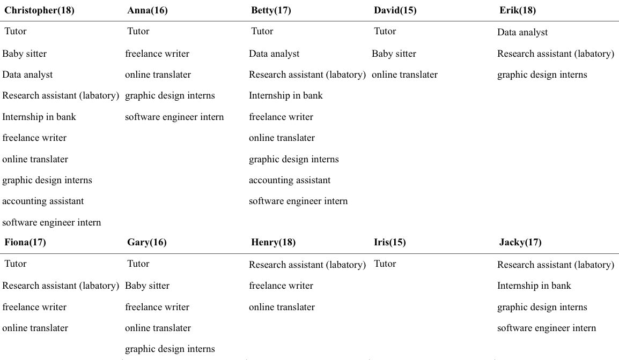

It is interesting to notice that there is a huge similarity between these ten fictional characters. For most of them, the jobs in the recommending clusters are tending to have a
TEAM #10549 Page 18 of 25

relatively high ability index. This is because we consider the ability requirement as part of
our evaluation indexes which jobs that have a high ability requirement would much likely to appear in the final recommendation. In addition, we can conclude that for jobs that appear several times like “tutor,” “online translator,” and “freelance writer,” they should become the top-list summer jobs for a typical high school student.

6. The Optimized Model
The optimization of our above model focuses on the input information from our high
school student user. Given that our target audience are high school students, it is unrealistic to expect them to compute their comparison matrix and input it completely accurately. It is very likely that the resulting input may be inconsistent; this will force the user to reenter the information, causing inconvenience.
In order to address comparison matrices that do not meet the consistency criterion, we will modify these to make them consistent based on the original information given.

6.1 Model Construction
We will first introduce the algorithm of our optimized model. Define the cosine value
of the angle between two n-dimensional vectors, , as the following:

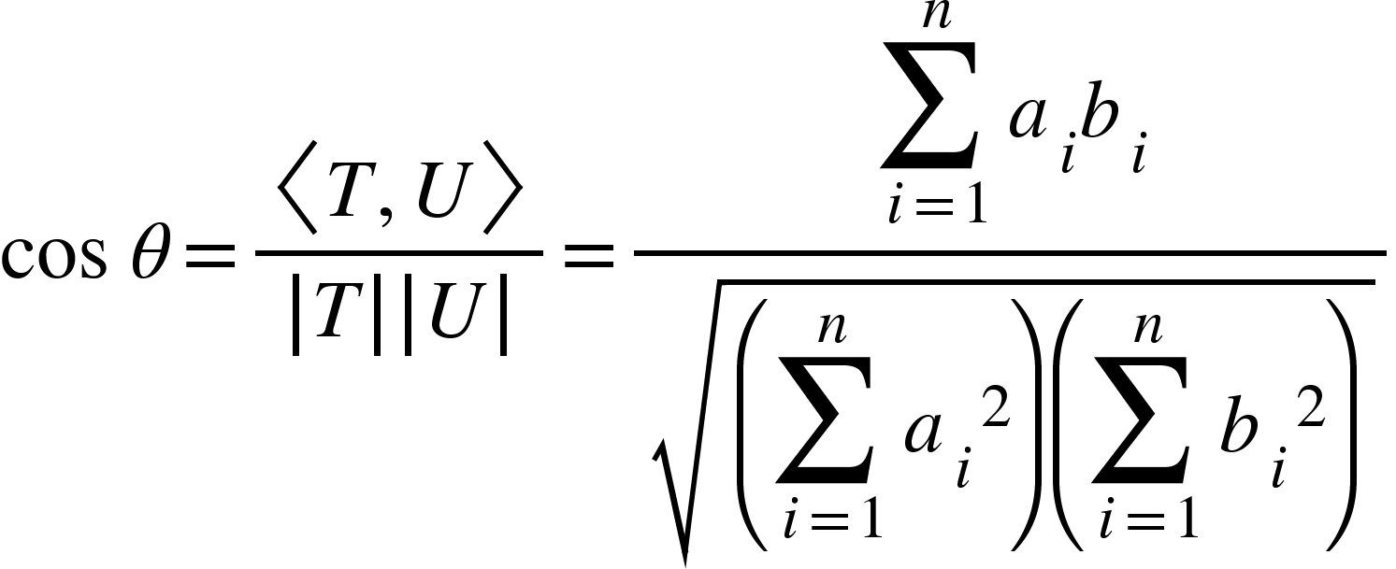


（1.1） where denotes the inner product of the two vectors T and U. Therefore, any two vectors correspond to one unique angle. Let A be some comparison matrix, such that its
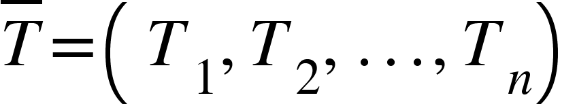
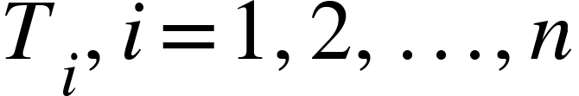
normalized matrix is , where are n-dimensional vectors. Therefore, the the normalized eigenvector of matrix C can be represented as:
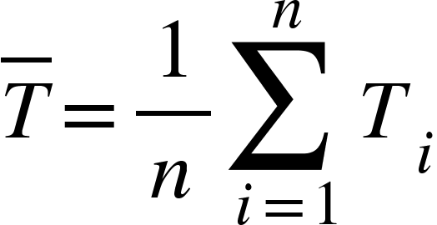
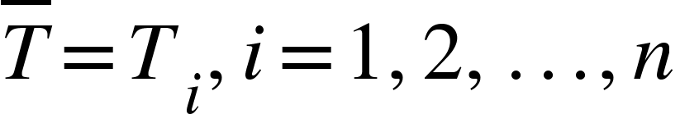
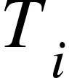

（1.2） If C is completely identical, then by definition . If C is not completely identical, then each can be related to with a similarity proportion, which can be


measured by the angle between the vectors. Since inconsistency in the comparison matrix is mostly caused by stochastic disturbance, so distributes around , the center. If we
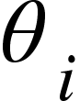

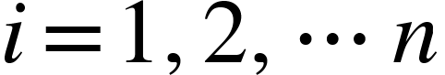


consider as the ideal estimation value, then we define for as the angle between and .
Subsequently, we define the following quantity:
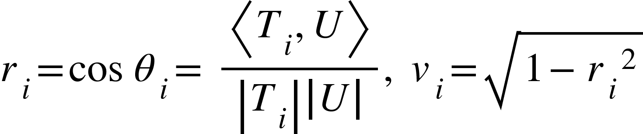

（1.3）
TEAM #10549 Page 19 of 25





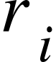

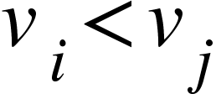


where is the consistency factor of relative to ; is the deviation of from . Hence, when , would have a better consistency than . When a comparison matrix fails to pass the consistency test, therefore, the terms with higher deviation need to be adjusted first.
Essentially, the adjustment method and algorithmic steps can be summarized as
below:
1. Normalize all comparison matrices that are not satisfactory or consistent.


2. Compute the consistency factor and deviation between each column vector and
the normalized eigenvector.
3. Based on the column vector with the smallest deviation, adjust the proportion of
reciprocal elements in the two column vectors with the largest deviations.
4. The process reiterates and tests the new matrix’s consistency until the result is
satisfactory enough.

6.2 Application of Optimized Model
In this subsection, we apply the above optimized model on a simplified hypothetical
case to test its effectiveness. Consider the following matrix C

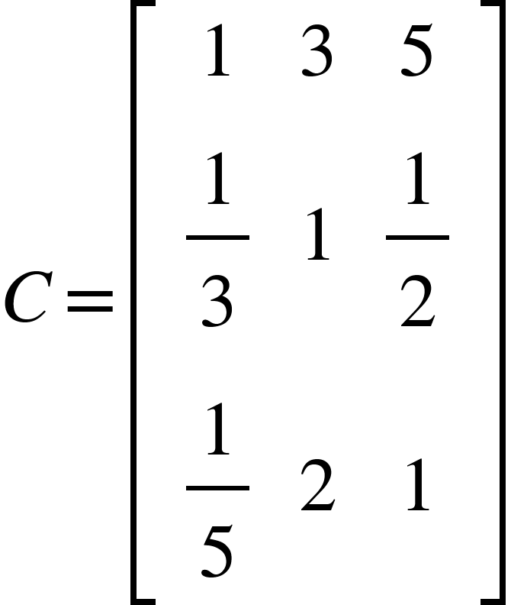

It has a CR=0.1407>0.1, failing to pass the consistency test. Utilizing the aforementioned method for optimization, we normalize the matrix to get
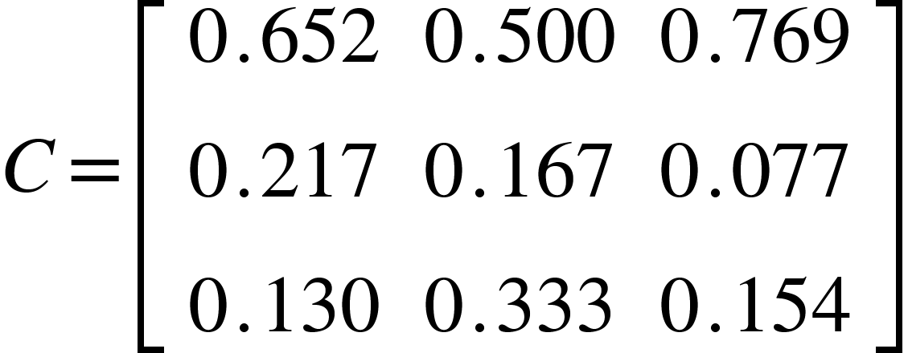

We can then compute the following:
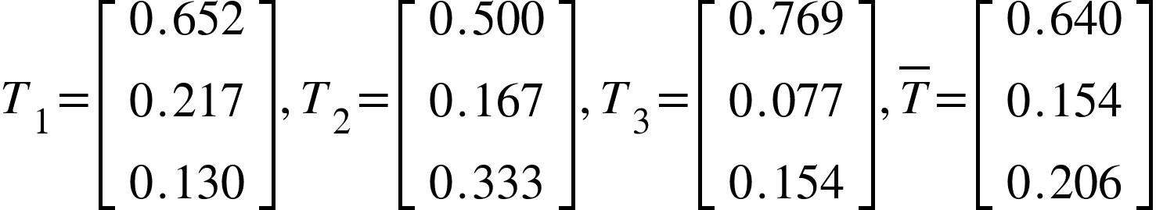

Based on these vectors, we calculate the deviation and the consistency factors:
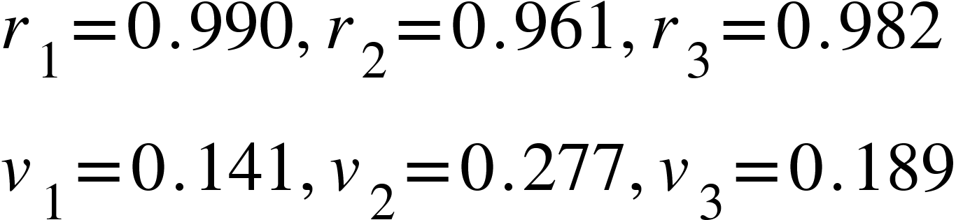




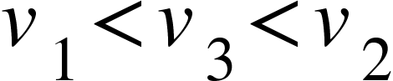
Since , has the best consistency, while has the worst consistency. Using as our caliber for adjustment, we can then derive the following adjusted matrix:
TEAM #10549 Page 20 of 25

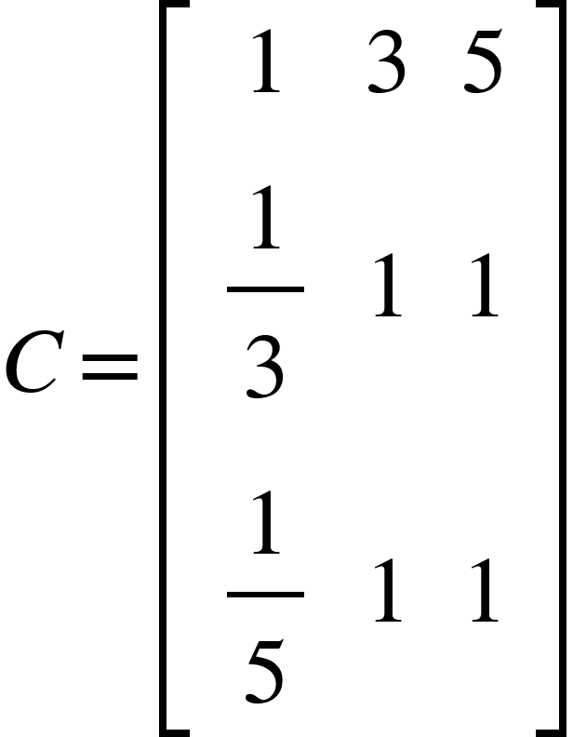

This gives a CR=0.025055<0.1, which now passes the consistency criterion. Therefore, by applying this optimized model that is capable of automatically improving the matrix’s consistency, it is evident that we could significantly reduce the need for users to re enter their information.

7. Evaluation of Model
In conclusion, our model incorporates the AHP model, entropy method, K-Means
clustering, and an optimized model to help recommend the best summer jobs to high school students. Some of our model’s overall strengths and weaknesses are summarized below:
7.1 Stengths
● While the problem does not provide any data, our model incorporates real life data we
have collected from over 20 different jobs. This makes the model realistic.
● Our model is fairly comprehensive, as it encompasses five categories of variables.
● Our fictional characters are quite representative of the US high school population.
● We utilize Entropy Method to offset the subjectivity in our AHP model, ensuring the
objective results to be objective.
● We consider the high probability that high school students may enter information that
is inconsistent; in response, we develop an optimized model that can make the matrix consistent that’s still based on original information.

7.2 Weaknesses
● The AHP model still has subjectivity that may negatively impact our model.
● We did not consider all the summer job options available to high school students.
● Our model only generalizes to the United States; we also did not consider
geographical differences at a smaller regional scale for each fictional individual. ● For indexes that can either be increasing or decreasing based upon each student's
reference, we only provide one possibility for our indexes. For instance, in our model, we only define the size of a company as an increasing index, but for some people,
they think a small company is better which corresponds to a decreasing index.

8. References
[1] Investopedia. ​https://www.investopedia.com/​. [2] Indeed. ​https://www.indeed.com/about​.
[3] Zipecruiter. https://www.ziprecruiter.com/.
[4] Payscale. https://www.payscale.com/.
TEAM #10549 Page 21 of 25

[5] Desilver, Drew. “In the U.S., teen summer jobs aren’t what they used to be.” https://www.pewresearch.org/fact-tank/2019/06/27/teen-summer-jobs-in-us/.
[6] Sari, B., Sen, T., & Kilic, S. E. (2007). Ahp model for the selection of partner companies in virtual enterprises. The International Journal of Advanced Manufacturing Technology, 38(3-4), 367-376. doi:10.1007/s00170-007-1097-6
[7] Lash, M., Wolcott, G., & Kahn, P. (1997). When Your Teenager is Injured: Preparing for Work and Adulthood. Research and Training Center in Rehabilitation and Childhood Trauma.
[8] Kissler, S., Tedijanto, C., Goldstein, E., Grad, Y., & Lipsitch, M. (2020, May 22). Projecting the transmission dynamics of SARS-CoV-2 through the postpandemic period. Retrieved November 16, 2020, from https://science.sciencemag.org/content/368/6493/860
[9] International Journal of Computer Science and Information Security, IJCSIS, Vol. 7, No. 1, pp. 292-295, January 2010, USA

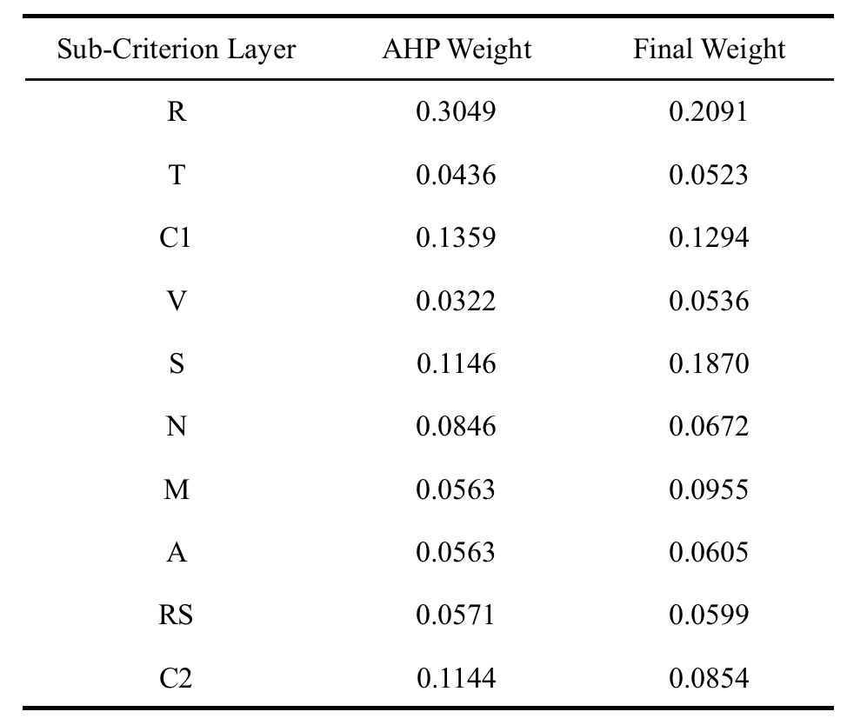
9. Appendix
9.1 Appendix A
Comparison matrices for the 10 fictional characters (sorted in alphabetical order):
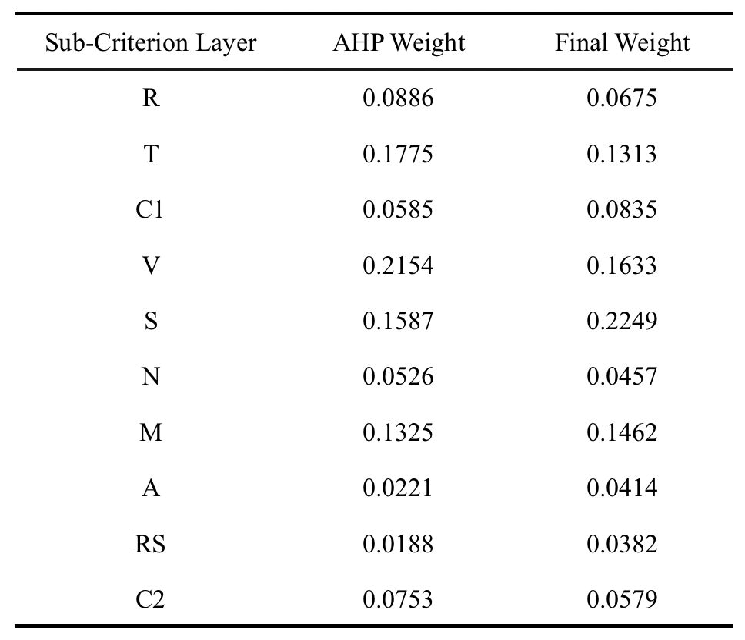
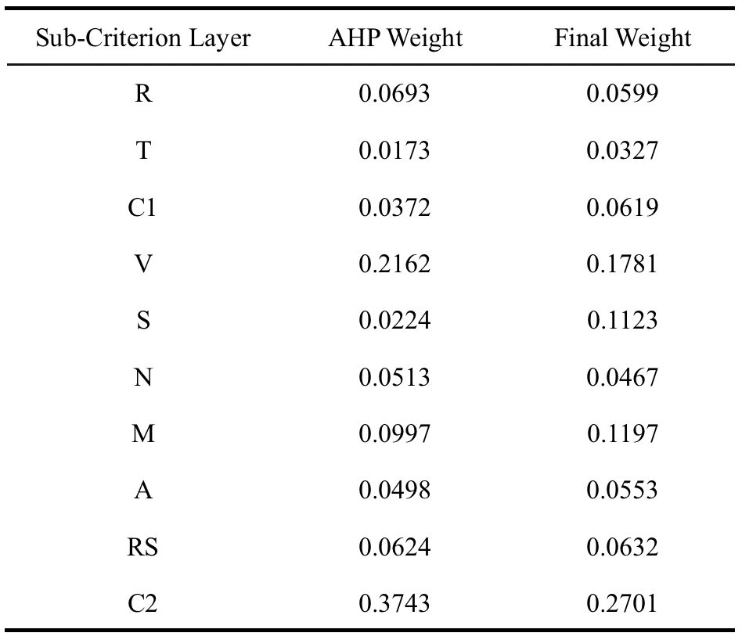
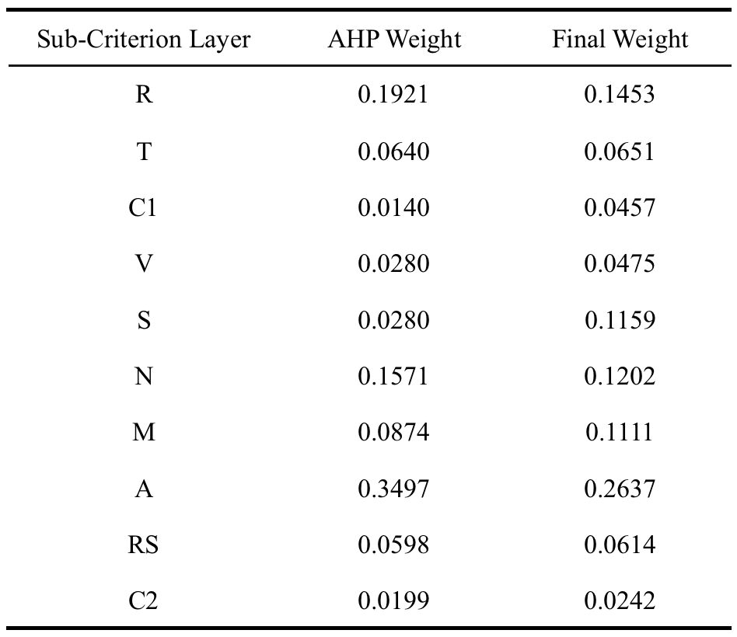
TEAM #10549 Page 22 of 25
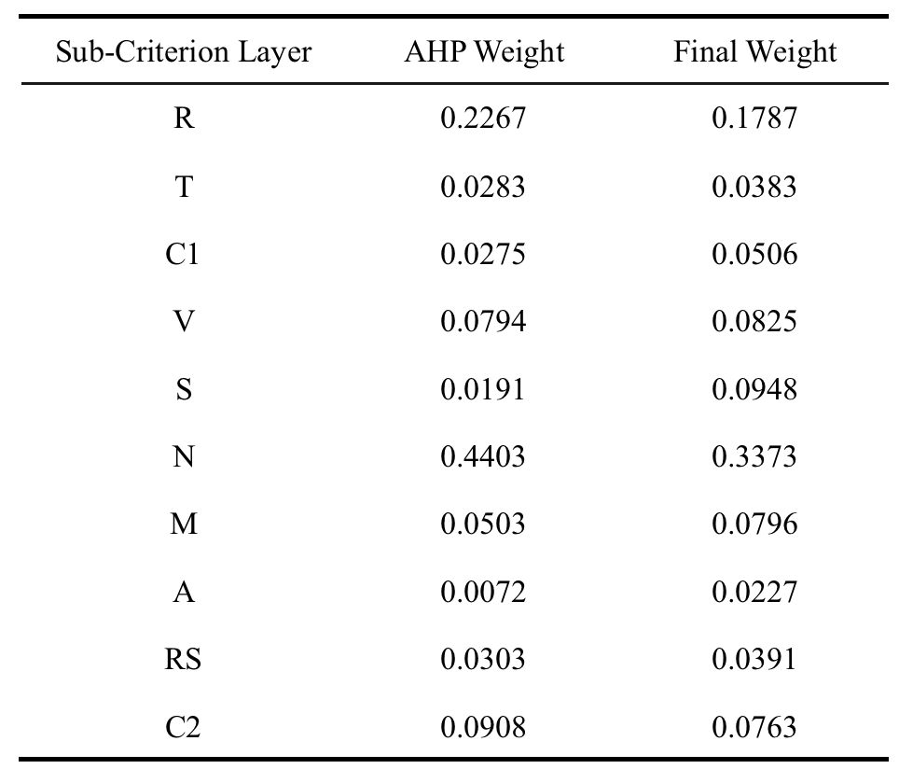
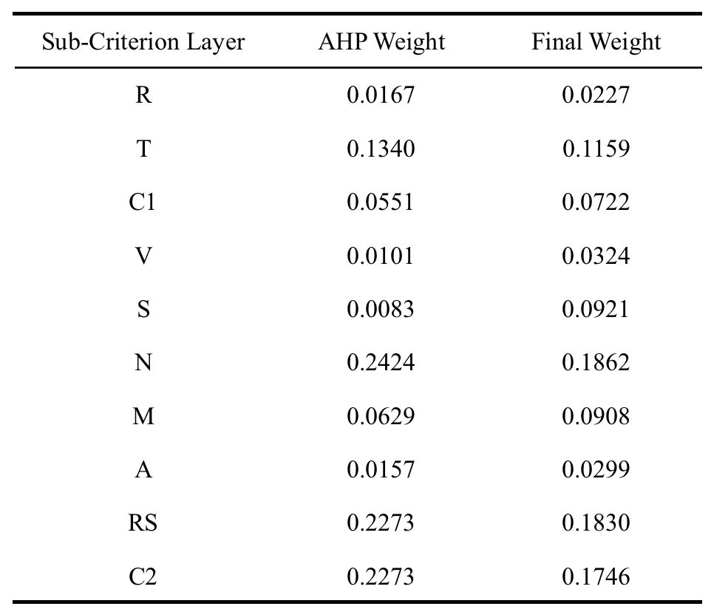
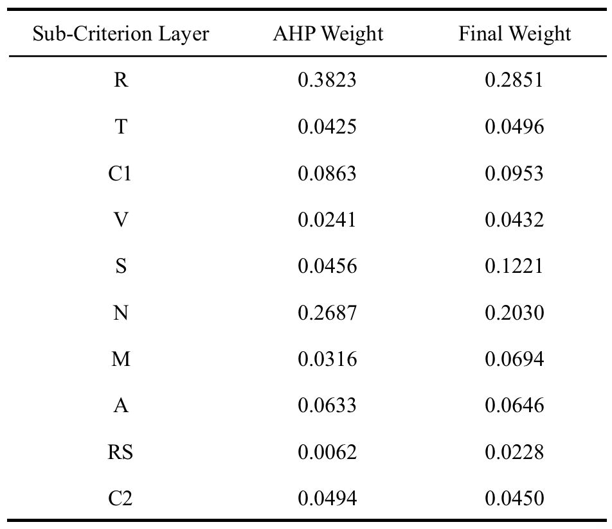
TEAM #10549 Page 23 of 25
TEAM #10549 Page 24 of 25

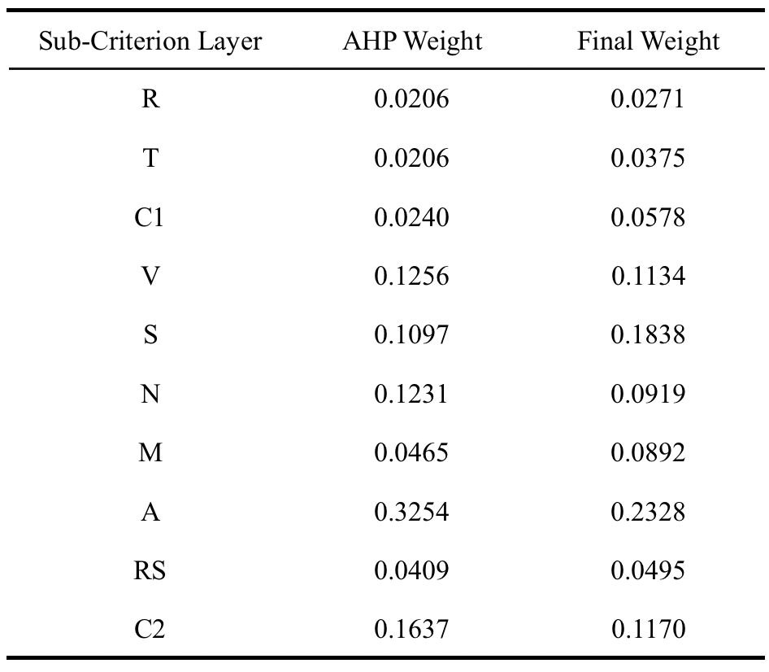

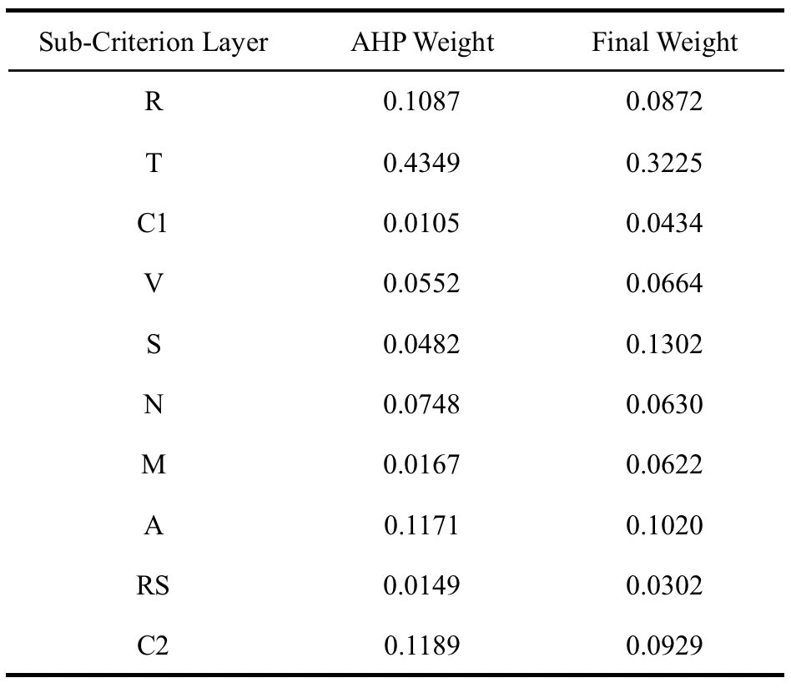

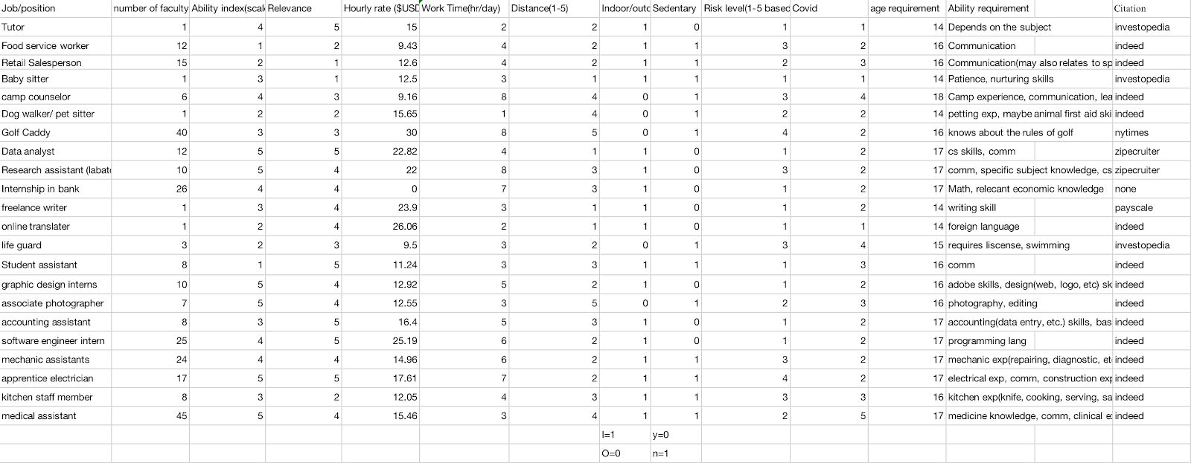
9.2 Appendix B
Summer Job List (22 sample jobs) for EWM and scoring analysis
TEAM #10549 Page 25 of 25

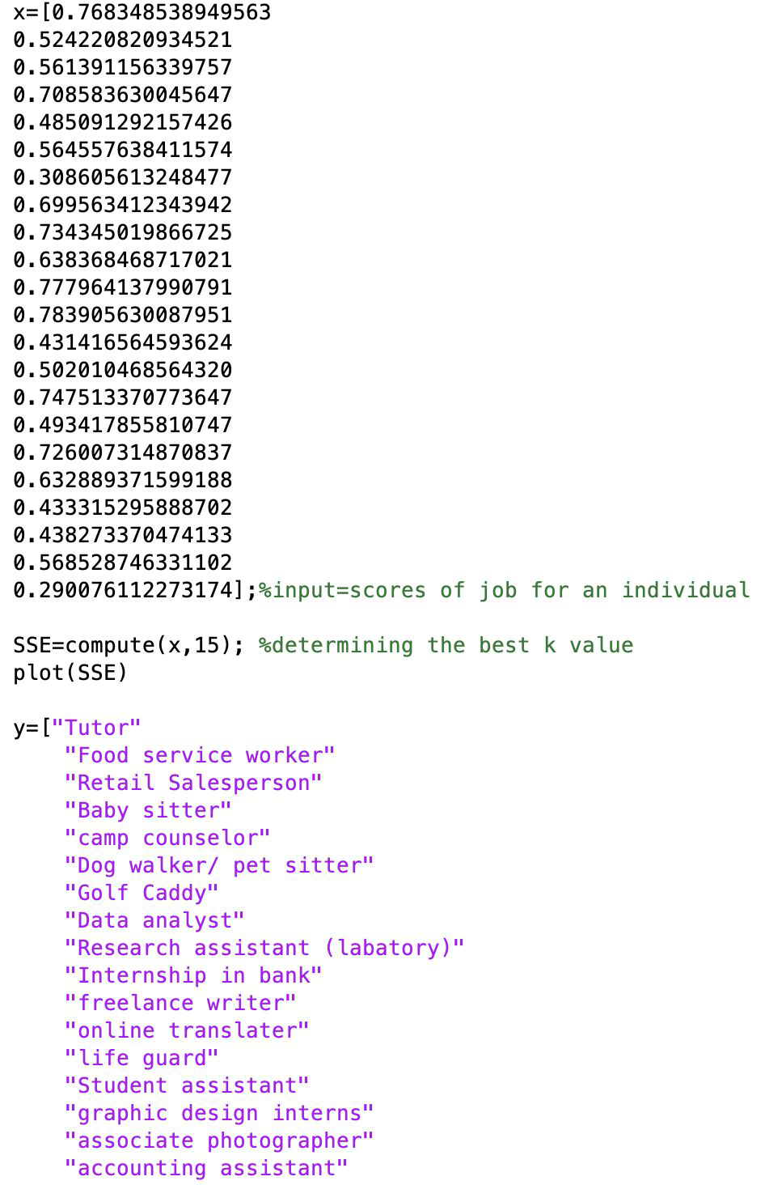
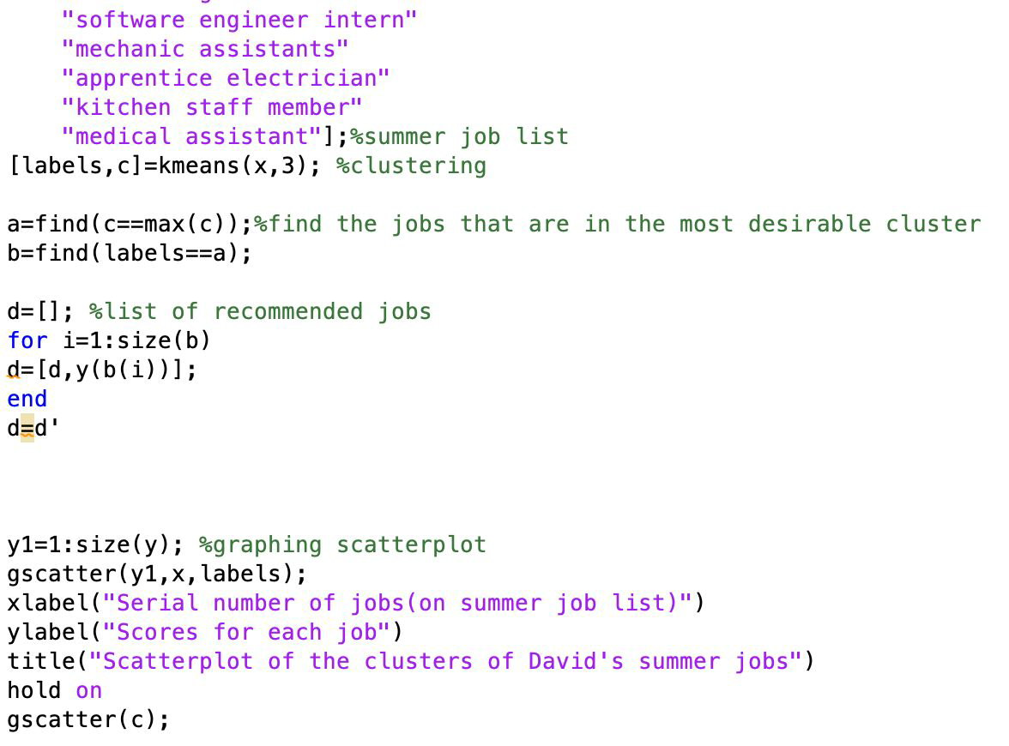
9.3 Appendix C
Code for K-means clustering:

